

|  |
| --- |
|  |
| Warehouse Management System (WMS)  MERN Stack Project |
| |  |  |  | | --- | --- | --- | | Al Amin | 7/9/24 | WMS-APPS | |

|  |  |
| --- | --- |
| **TABLE OF CONTEXT** | |
| 1. **Purpose** | **01** |
| 1. **Scope** |  |
| 1. **Technology** |  |
| 1. **Features** |  |
| 1. **User Manual** |  |
| 1. **Report Panel** |  |
|  |  |

# **Purpose**

Proper documentation and tracking are the key of warehouse management. This Apps created to simplify the daily warehouse operations, with this Apps you can manage live stock with proper storage location. Also, can track the goods movement.

# **Scope**

This apps usually created based on RAW material warehouse, but it can be applied any types of industrial operation.

# **Technology**

This Apps build on world most popular and faster and dynamic MERN technology. Which is open source–centric collection of technologies that uses JavaScript for both the browser and server sides of a web application. MERN is an acronym for the four technologies that form the stack: MongoDB, Express, React, and Node.

## **MongoDB**

MongoDB is a document database. It stores data in a type of JSON format called BSON. MongoDB is one of the large-scale database management for growing enterprise applications.

## **ExpressJS**

Express is a minimal and flexible NodeJS web application framework that provides a robust set of features for web and mobile applications. APIs.

## **ReactJS**

React is a free and open-source front-end JavaScript library for building user interfaces based on components by Facebook Inc. It is maintained by Meta and a community of individual developers and companies. React can be used to develop single-page, mobile, or server-rendered applications with frameworks.

## **NodeJS**

NodeJS is a cross-platform, open-source JavaScript runtime environment that can run on Windows, Linux, Unix, macOS, and more. NodeJS runs on the V8 JavaScript engine, and executes JavaScript code outside a web browser. NodeJS lets developers use JavaScript to write command line tools and for server-side scripting.

# **Features**

This app is designed to focus on the basics of inventory. Here the following points are considered-

## **Users**

This is the basic features in a application to define users role and responsibilities. Here follow the manual user adding process because this is an enterprise level apps, so user list should restrict by organization and it will create by employee ID. Total 4 types of user can be resister-

* Admin
* LM (Line Manager)
* Checker
* User (Default)

Admin can add/remove user based on requirement, also can change the responsibility based on above option. And can be reset the password also.

## **Items**

Based on items details all warehouse operation will flow. In item database below information will be preserve-

* Item Code/Number/ID
* Item Name/Description
* Item UOM (Unit of measurement)

LM & Admin can add the new item and only Admin can edit/delete the item details if required. **But remember, which item transaction is happened that item should not delete it.**

## **Lots**

Basically, lot maintain in production RAW material warehouse, It could be maintain in trading goods warehouse and finished goods warehouse also. Actually, lot is the very basic requirements of your storage items. So here you can maintain-

* Model/Variant
* Lot Number/Trucking

LM/Admin can add the new lot. But Only Admin can applicable for edit/remove the lot information.

## **Locations**

Location is the most important part of warehouse storage. If you can trace the location properly then you can find the product/goods easily and faster. Also, you can audit/reconcile your items correctly. So here you can maintain-

* Location Name/Identity

LM/Admin can add the new location. But Only Admin can applicable for edit/remove the location information.

## **Stations**

Station means your customer. Which end you want to deliver your product/goods. This option is necessary to add for your goods issue from warehouse. So here you can maintain-

* Station/Customer/Party Name

LM/Admin can add the new station. But Only Admin can applicable for edit/remove the station information.

## **Receive**

In this module you can receive your items/goods with the necessary information, So here you can record-

* Receive Date
* LC Number/Info
* Invoice/Challan Number/ Info
* Bill of entry/VAT info
* Purchase Order Info
* Lot Info (Pre-define only)
* Item Qty
* Order info
* Storage Location (Pre-define only)
* Remarks

LM/Admin can receive the items/goods. But Only Admin can applicable for edit/remove the receive information.

## **Issue**

In this module you can issue your warehouse items based on received. So here you can record-

* Issue Date
* Issue Station
* Issue Lot
* Item/Goods (Ensure Location & On-hand Qty)
* Issue Qty
* Remarks

User/Checker/LM/Admin can create issue order with this module. But Only Admin can applicable for edit/remove the issuer order information.

## **Checklist**

Initially all issue order will consider waiting and this list will show the checklist module. Here Checker can able to verify the issue movement. Basically, two types of activities are Done or Reject. Based one checking, checker can accept or reject the issue order. And this list will show as per line items.

# **Database Design**

At first need to understand the data flow in backend of this apps-

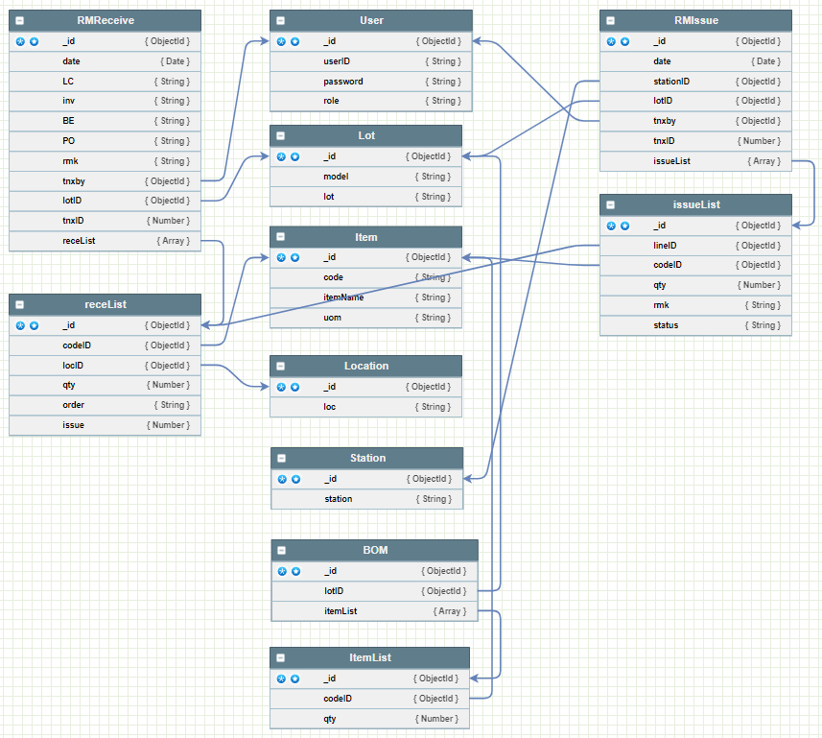

Based on above flow API’s created and maintain database in MongoDB

# **Usages Module**

How to use this apps in UI/UX mode, that details will describe-

## **User Master**

Admin can be maintained user master as per requirement –

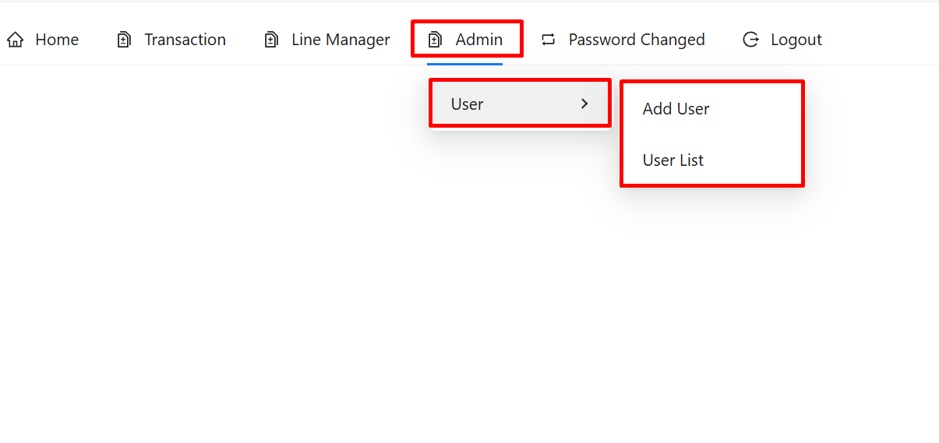

### **Add User**

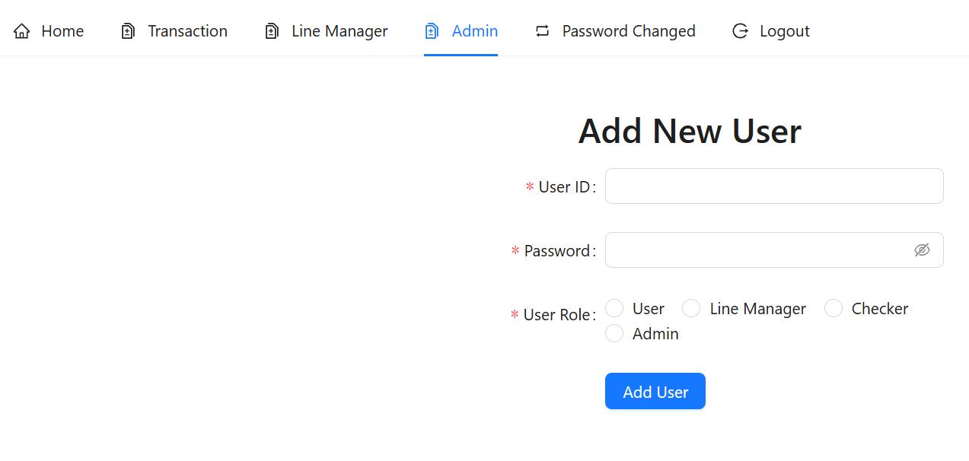

Related information and role should be fill-up to add new user.

#### **Consideration:**

* User ID Should be unique.
* User Role should be defined as per user responsibilities.

#### **Validates:**

* Duplicate User ID will not able to add.
* If User ID exist in database then a pop-message will show like: “User Already created”.
* Password will be encrypted, other than the user no one can't login to his ID.
* “Part UOM updated” message will be displayed for added new user.

### **User List**

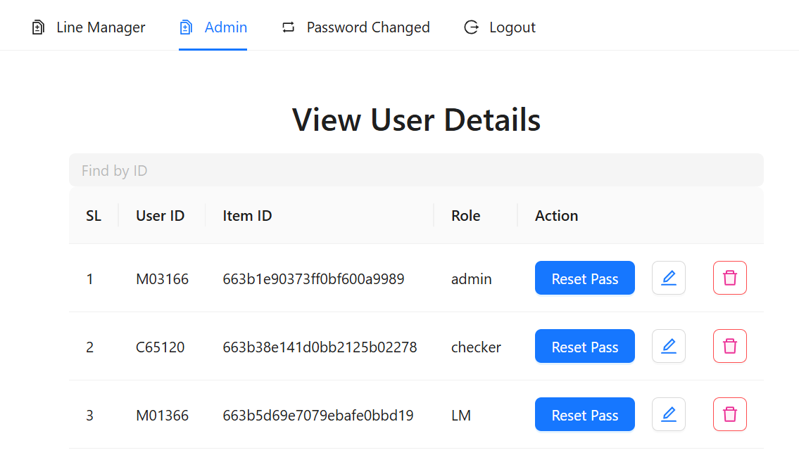

Admin can able to view the user detail in **User** > **User List**

Here a search option available. Based on User ID can able to find any user details here also can be edit/remove.

#### **Editable Data:**

After click on the particular edit icon new modal will be open for edit existing data-

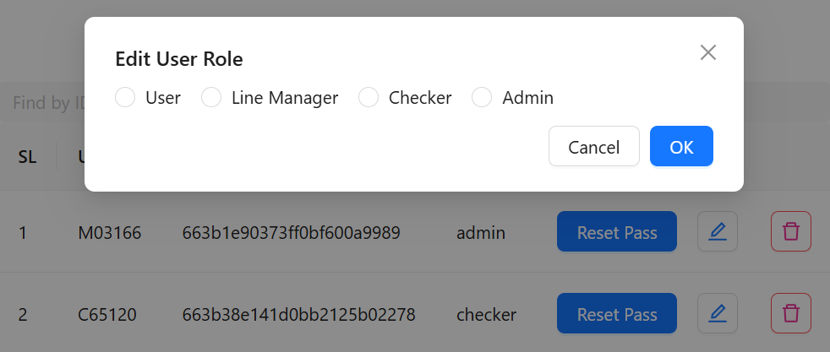

With in this modal admin can update the user responsivities.

Also, can able to reset password if required. And the rest password will be “**password**”

#### **Consideration:**

* **Be sure before changes any role of user, based on role many options will be available or restrict.**
* **If admin rest the password then existing password will not work.**
* **Deleting users may affect the report panel, so be careful when deleting users.**

#### **Validates:**

* For reset password, no need to do anything, just click on reset password.
* Reset password also encrypted.
* “User Role updated” message will be displayed for update new role.

## **Item Master**

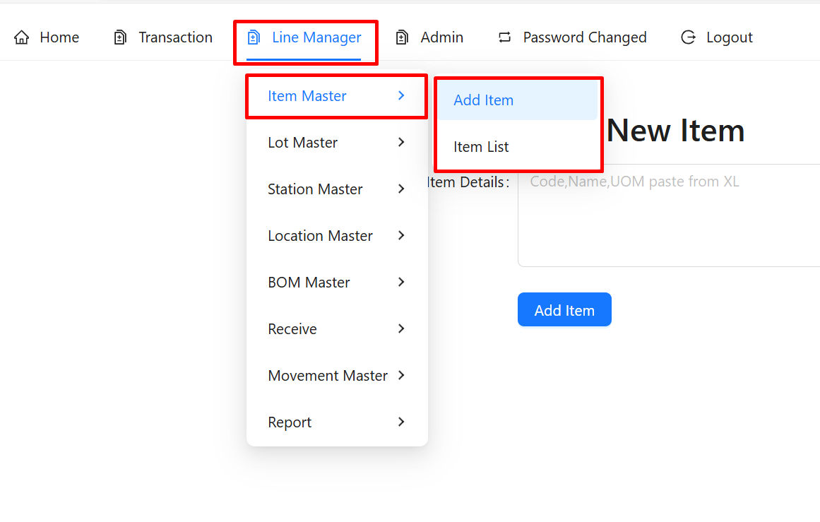

Item Master has two types of module-

### **Add Item**

When need to add new item that time required 3 information-

* Item Code/Number/ID
* Item Name/Description
* Item UOM (Unit of measurement)

First above 3 information collect on Excel workbook in parallel column like below-

|  |  |
| --- | --- |
| Excel Module | Apps Module |
|  |  |

After that copy 3 column data without heading and past into the input box of the **Add new Item** Module. Then submit this data by clicking on **Add Item** button.

#### **Consideration:**

* Make sure unique data in single operation.
* Avoid blank row/column.
* Avoid extra row/column.
* Maintain same data collection as per given sequence (Code | Name | UOM)

#### **Validates:**

* If any previous item code overlaps with the new item, it will not be re-added.
* “No New Item Found” message will be displayed if all items overlap.
* “Only New Item Added” message will be displayed if partial items overlap.

### **Item List**

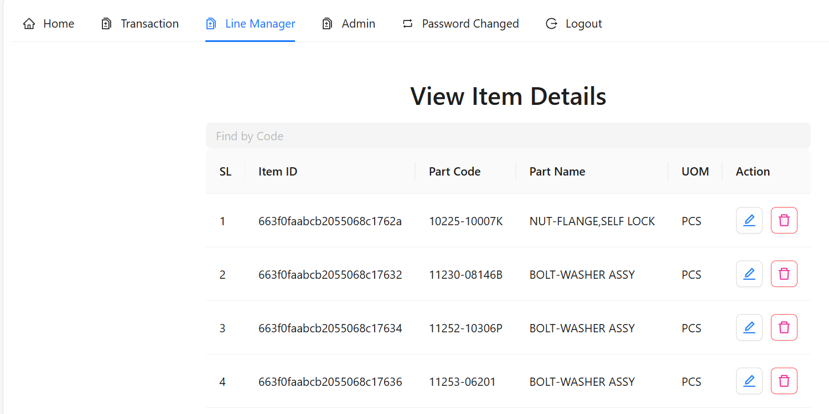

LM/Admin can able to view the item detail in **Item Master** > **Item List**

Here a search option available. Based on item code can able to find any item details here also can be edit/remove.

#### **Editable Data:**

After click on the particular edit icon new modal will be open for edit existing data-

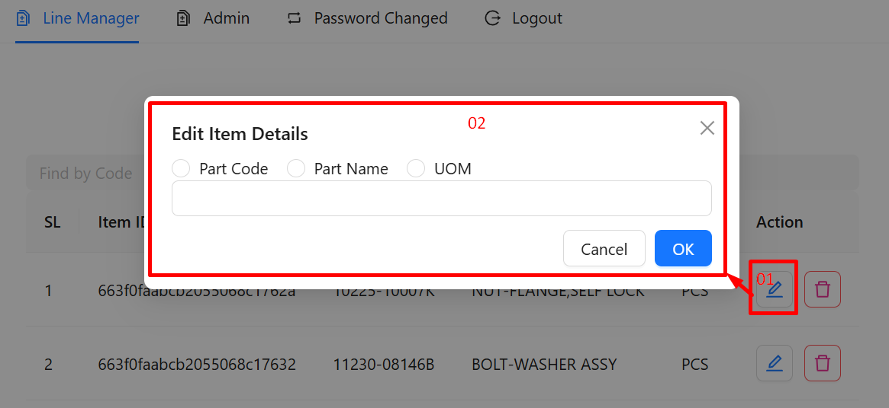

In this modal you can select the radio button to change the particular item data. Like- Code or Name or UOM. And the updated data can be written on the input box, then click ok to update the data.

#### **Consideration:**

* Make sure changes data by click on the radio option.
* Before changes check the updateable information with existing item list is available or not?
* **Deleting item may affect the report panel, so be careful when deleting item.**

#### **Validates:**

* Backend able to update particular item on particular fields data.
* “Part Code updated” message will be displayed if code fields data updated.
* “Part Name updated” message will be displayed if name fields data updated.
* “Part UOM updated” message will be displayed if name fields data updated.

## **Lot Master**

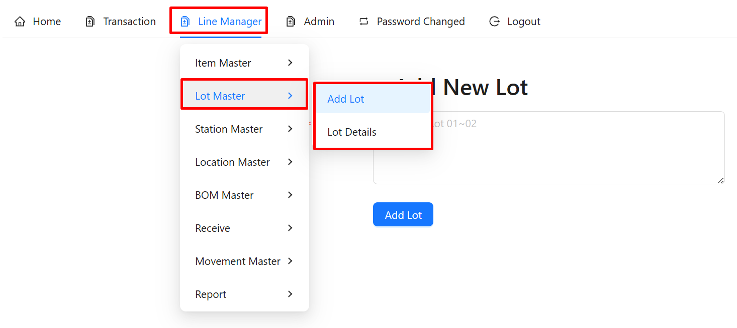

Lot Master has two types of module-

### **Add Lot**

When need to add new lot that time required 2 information

* Model/Variant
* Lot Number/Info

Based above two information need to make a list on Excel like below

|  |  |
| --- | --- |
| Excel Module | Apps Module |
|  |  |

After that above data copy only combined column C without heading and past into the input box of the **Add new Lot** Module. Then submit this data by clicking on **Add Lot** button.

#### **Consideration:**

* Make sure unique data in single operation.
* Avoid blank row/column.
* Avoid extra row/column.
* Maintain same data collection as per given sequence (Model_Lot).
* Don’t forget to put “_” between model & Lot.

#### **Validates:**

* If any previous lot overlaps with the new lot, it will not be re-added.
* “New Lot Not Found” message will be displayed if lot overlapping.
* “Only New Lot Added” message will be displayed if partial lot added.
* Based on Lot data model will be segregate and update in database.

### **Lot Details**

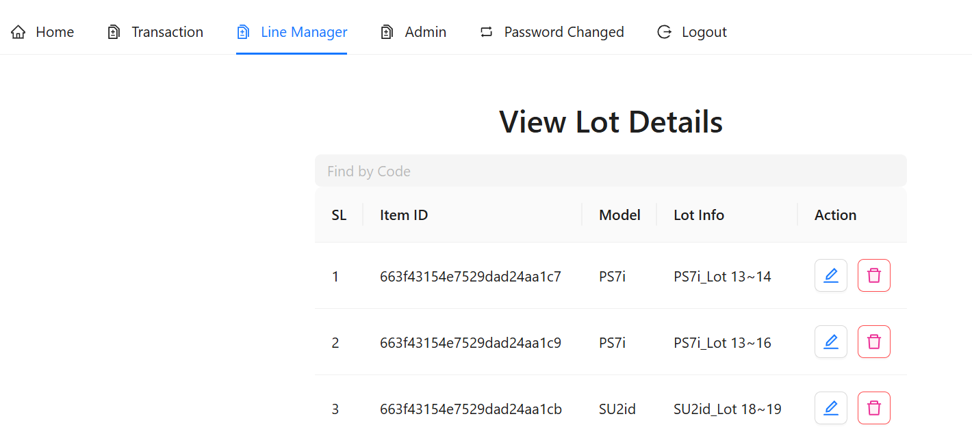

LM/Admin can able to view the lot details in **Lot Master** > **Lot Details**

Here a search option available. Based on lot info can able to find any details here also can be edit/remove.

#### **Editable Data:**

After click on the particular edit icon new modal will be open for edit existing data-

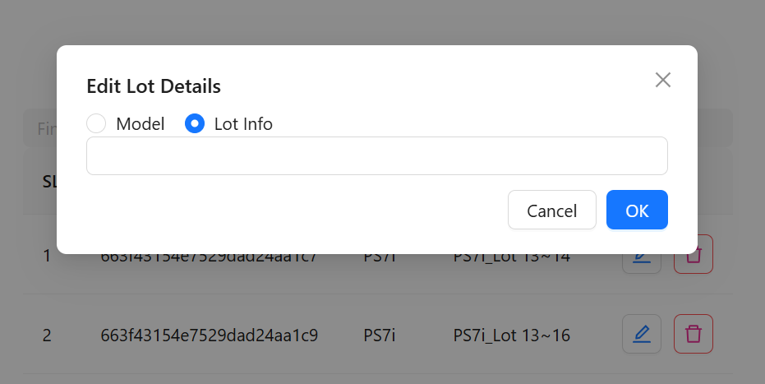

In this modal you can select the radio button to change the particular data. Like- Model or Lot Info. And the updated data can be written on the input box, then click ok to update the data.

#### **Consideration:**

* Make sure changes data by click on the radio option.
* Before changes check the updateable information with existing list is available or not?
* **Deleting item may affect the report panel, so be careful when deleting item.**

#### **Validates:**

* Backend able to update particular item on particular fields data.
* “Model updated” message will be displayed if model fields data updated.
* “Lot updated” message will be displayed if lot info fields data updated.

## **Station Master**

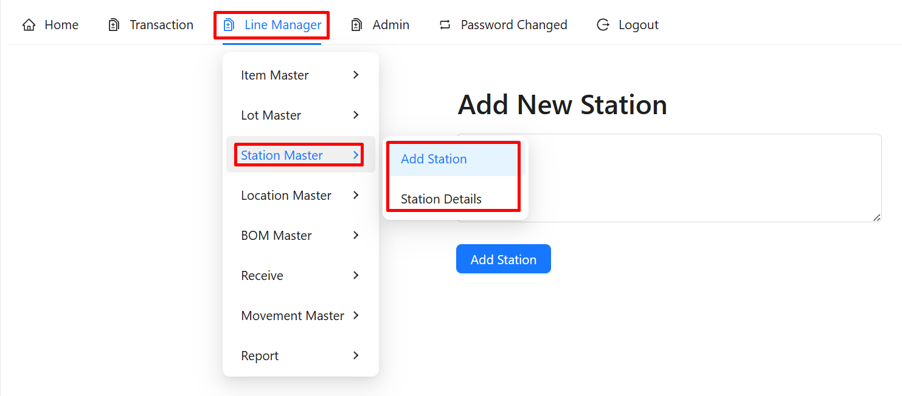

Station Master has two types of module-

### **Add Station**

When need to add new station that time required below information

* Station/Customer/Party Name

Based above information need to make a list on Excel like below

|  |  |
| --- | --- |
| Excel Module | Apps Module |
|  |  |

After that above data copy without heading and past into the input box of the **Add new Station** Module. Then submit this data by clicking on **Add Station** button.

#### **Consideration:**

* Make sure unique data in single operation.
* Avoid blank row/column.
* Avoid extra row/column.
* Maintain same data collection as per given format.

#### **Validates:**

* If any previous station overlaps with the new station, it will not be re-added.
* “New Station Added” message will be displayed for adding.

### **Station Details**

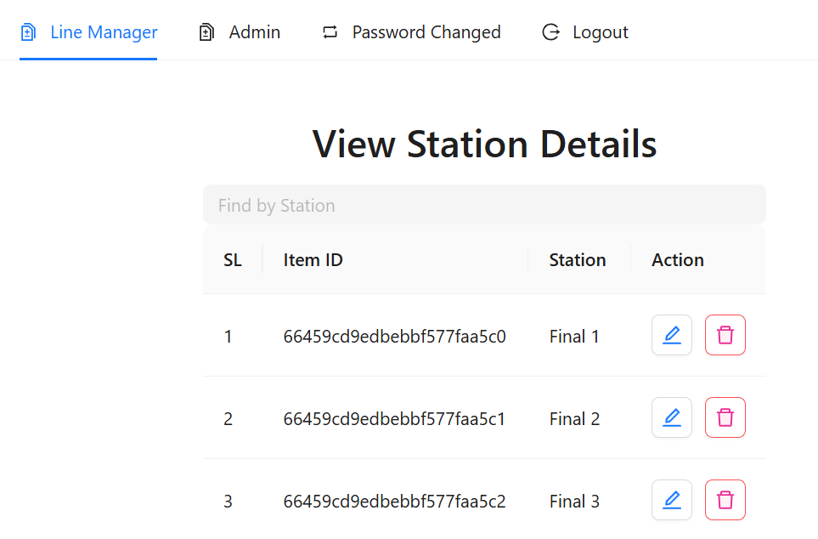

LM/Admin can able to view the station details in **Station Master** > **Station Details**

Here a search option available. Based on station info can able to find any details here also can be edit/remove.

#### **Editable Data:**

After click on the particular edit icon new modal will be open for edit existing data-

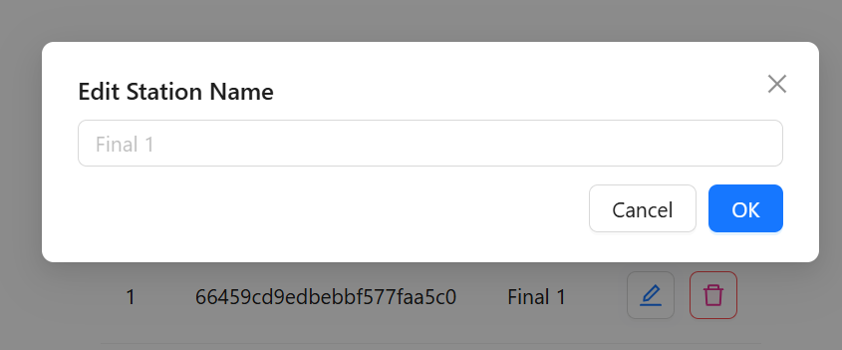

In this modal you can change the station name. And the updated data can be written on the input box, then click ok to update the data.

#### **Consideration:**

* Before changes check the updateable information with existing list is available or not?
* **Deleting item may affect the report panel, so be careful when deleting item.**

#### **Validates:**

* Backend able to update particular item on particular fields data.
* “Station Name updated” message will be displayed if fields data updated.

## **Location Master**

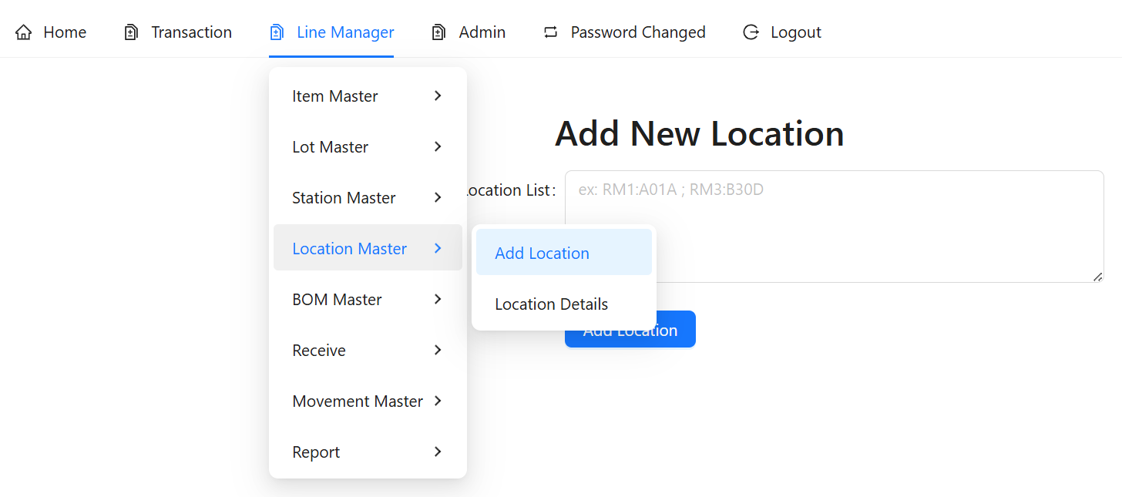

Location Master has two types of module-

### **Add Location**

When need to add new location that time required below information

* Location Name/ID/Number

Based above information need to make a list on Excel like below

|  |  |
| --- | --- |
| Excel Module | Apps Module |
|  |  |

After that above data copy without heading and past into the input box of the **Add new Location** Module. Then submit this data by clicking on **Add Location** button.

#### **Consideration:**

* Make sure unique data in single operation.
* Avoid blank row/column.
* Avoid extra row/column.
* Maintain same data collection as per given format.

#### **Validates:**

* If any previous location overlaps with the new location, it will not be re-added.
* “New Location Added” message will be displayed for adding.

### **Location Details**

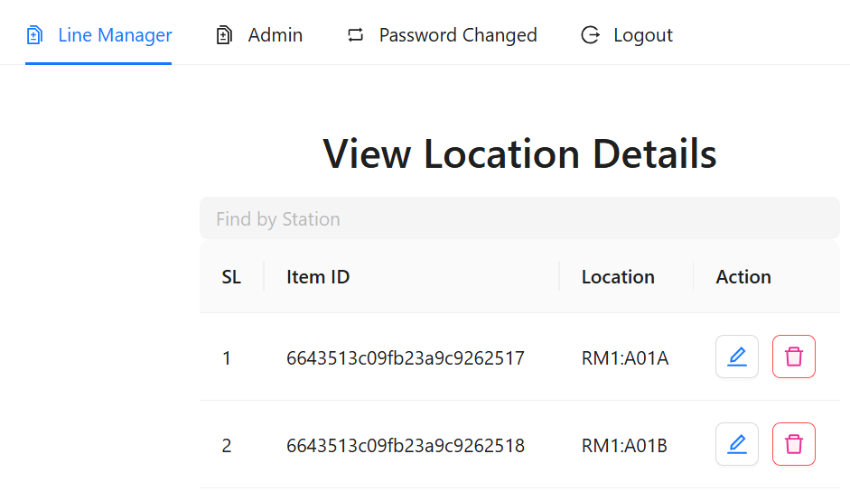

LM/Admin can able to view the station details in **Location Master** > **Location Details**

Here a search option available. Based on location info can able to find any details here also can be edit/remove.

#### **Editable Data:**

After click on the particular edit icon new modal will be open for edit existing data-

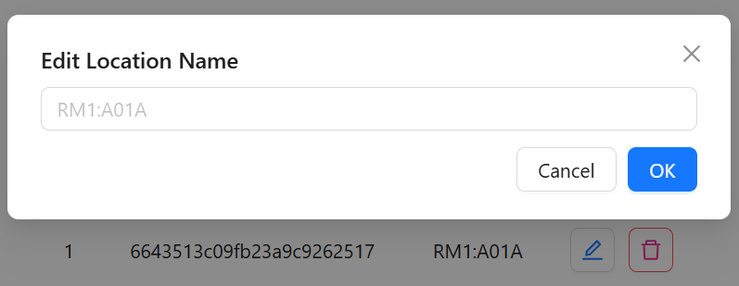

In this modal you can change the station name. And the updated data can be written on the input box, then click ok to update the data.

#### **Consideration:**

* Before changes check the updateable information with existing list is available or not?
* **Deleting item may affect the report panel, so be careful when deleting item.**

#### **Validates:**

* Backend able to update particular item on particular fields data.
* “Location Name updated” message will be displayed if fields data updated.

## **BOM Master**

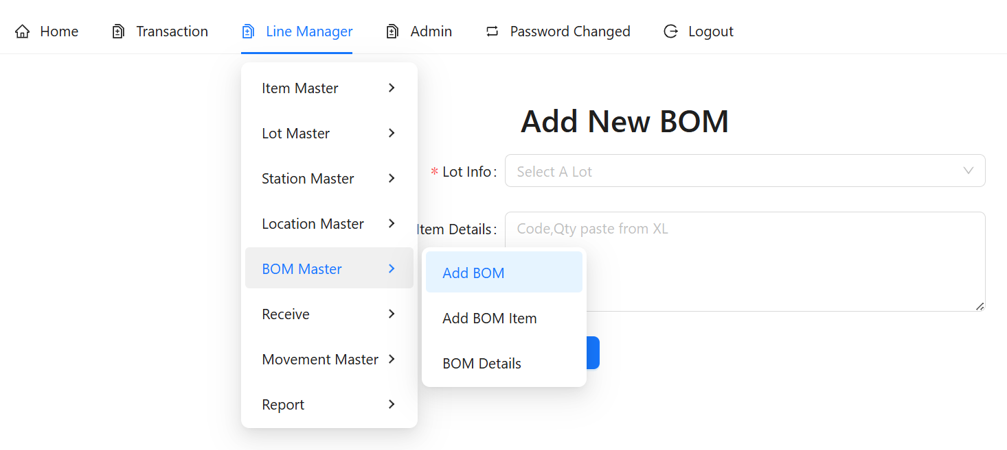

BOM Master has three types of module-

### **Add BOM**

When need to add new BOM that time required below information

* Select exact Lot
* BOM Item Code
* BOM Item used qty

Based above information need to make a list on Excel like below

|  |  |
| --- | --- |
| Excel Module | Apps Module |
|  |  |

After that above data copy without heading and past into the input box of the **Add new BOM** Module. Then submit this data by clicking on **Add BOM** button.

#### **Consideration:**

* Make sure unique data in single operation.
* Avoid blank row/column.
* Avoid extra row/column.
* Maintain same data collection as per given format.

#### **Validates:**

* If any previous BOM overlaps with the new BOM, it will not be re-added.
* “BOM Exist, Use Single input Option” message pop up for existing BOM.
* If BOM already exist then use second option **BOM Master > Add BOM Item**
* “New BOM Added” message will be displayed for new adding.

### **Add BOM Item**

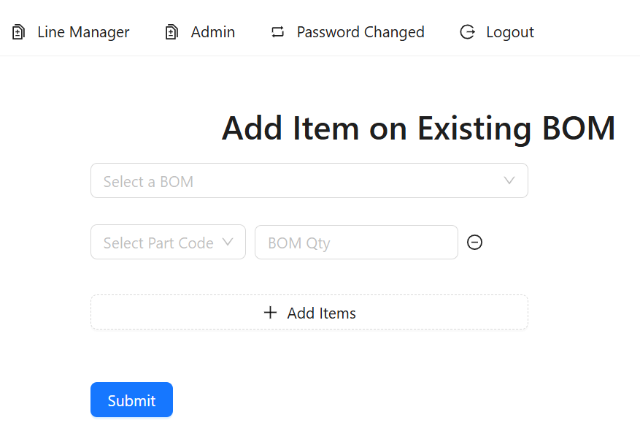

LM/Admin can able to add new item in existing BOM in **BOM Master** > **Add BOM Item**

#### **Data Upload process:**

Below steps need to follow-

* First need to select the existing Lot from the drop-down.
* Second Need to click on **+Add Items** button.
* Third need to select Item code from the drop-down list.
* Fourth need to input BOM usages qty.
* If need to add another item then again click to the **+Add Items**
* Finally need to submit this data for adding new item in the existing BOM.

#### **Consideration:**

* Before add new item in the BOM need to check the updateable information with existing list is available or not?
* **Need to confirm particular BOM exist or not?**

#### **Validates:**

* Backend able to update particular item on particular BOM data.
* “BOM not exist” message will be displayed if selected BOM not exist.
* “New Item added on BOM” message will be displayed if new item added.

### **View BOM Details**

Need to functional….

# **Report Panel**

# **Do’s & Don’ts**

# **Conclusion**